WEEKLY REPORT DE BENEDETTI MATTEO
WEEK 16: 16/12/2019 - 20/12/2019
IMAGE OVERLAP PERCENTAGE:
The Image Overlap Percentage (IOP) does not change for the same IFD at different speed, as long the camera position and orientation is constant, which is the case of the LocCam.
IFD [meters] | IOP [percentage]
0.01 | 99.5183
0.03 | 98.5573
0.06 | 96.6314
0.1 | 95.1901
0.2 | 90.3966
0.3 | 85.6191
0.5 | 76.1132
0.75 | 64.3218
1.0 | 52.6323

The tests in the previous report showed that the VO performances, in those conditions, decrease for IFD bigger than 0.3 m and IOP smaller than 85%.

BETTER LOOK AT SMALL IFD AT FAST SPEED
These tests may suggest that and IFD smaller than 0.1m (and therefore IOP higher than 93%) leads to a small decrease in performances.
Though this behavior is not present at the same magnitude in the next tests at slower speed.
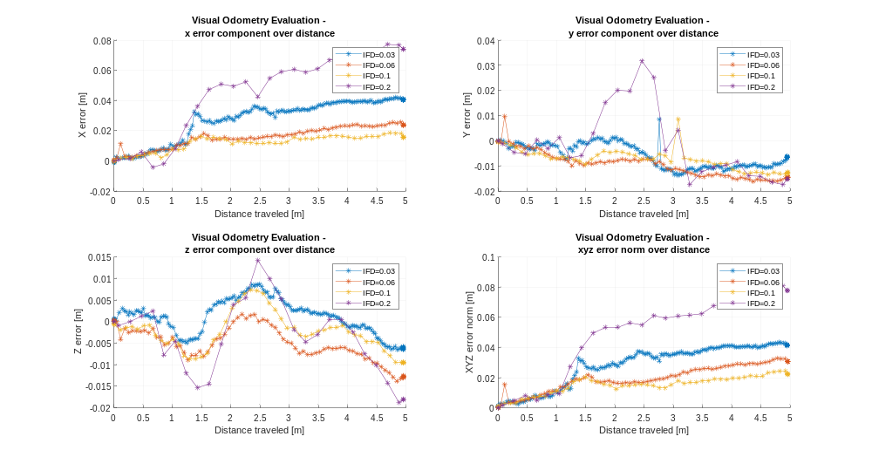
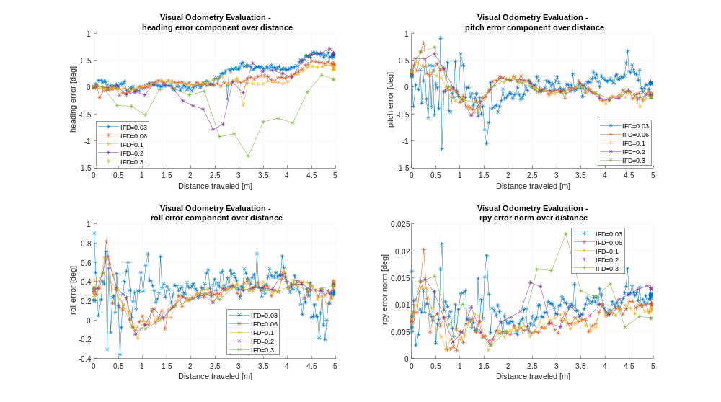

BETTER LOOK AT SMALL IFD AT SLOW SPEED
A low speed makes it possible to also achieve an IFD = 0.01m, while at 0.07m/s the best is IFD = 0.03m and IOP = 92%
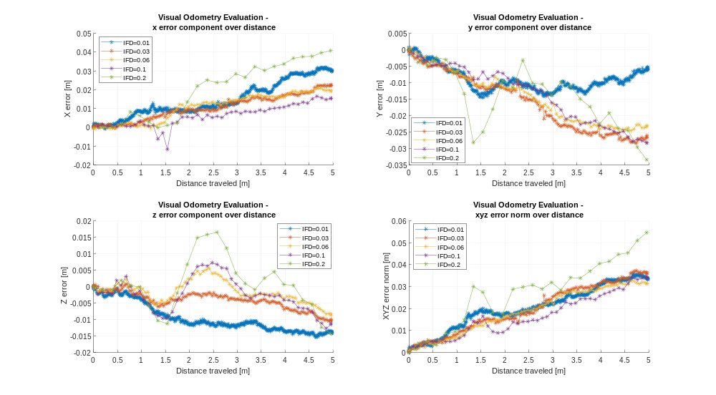
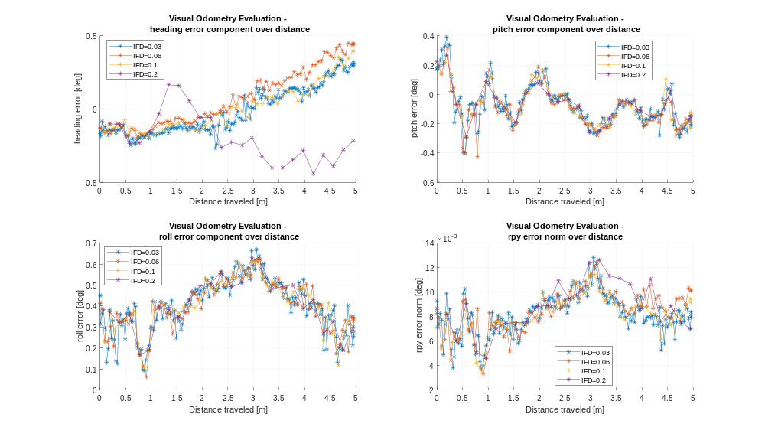
In these low speed tests the IFDs below 0.1m and IOPs above 86% appear to perform very similarly, without any noticeable decrease in case when the IFD gets too low.

BODY NAVCAM TRANSFORMATION REFINEMENT:
VO with the navcam now works and the transform has been refined as usual
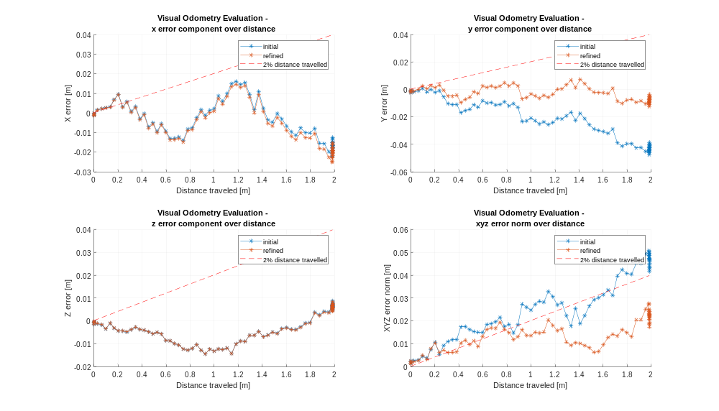
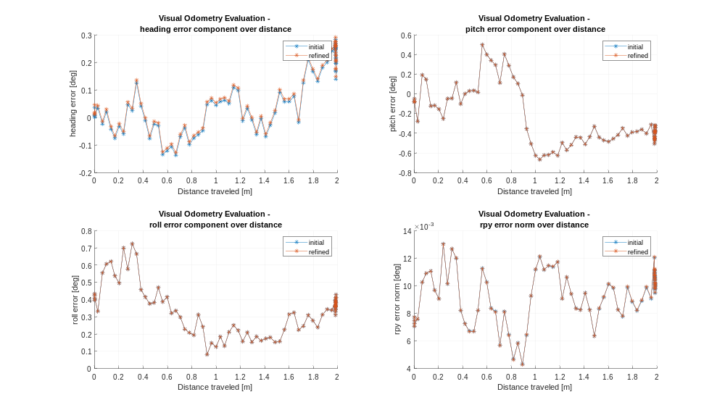
NAVCAM TESTS AT DIFFERENT PITCH VALUES:
Speed = 0.07 m/s, Pitch varied from 20 deg to 50 deg, VO frequency = 0. 2332 Hz, IFD = 0.3 m
navcam pitch = 20deg – IOP = 99.99%
navcam pitch = 30deg – IOP = 94.9343%
navcam pitch = 40deg – IOP = 83.9429%
navcam pitch = 50deg – IOP = 72.5842%
loccam pitch = 30deg – IOP = 85.6191%
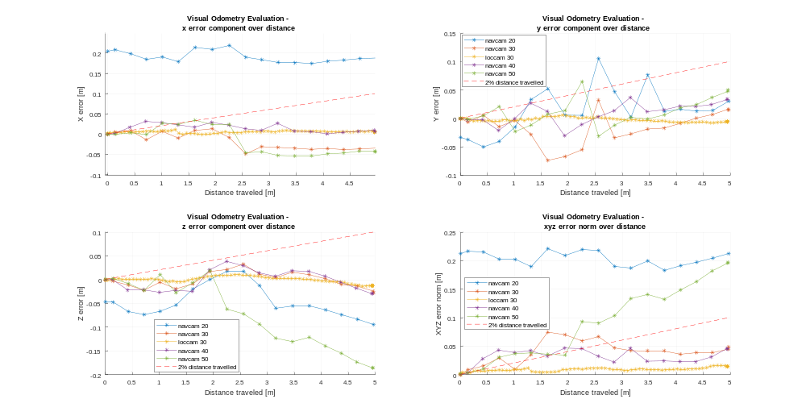
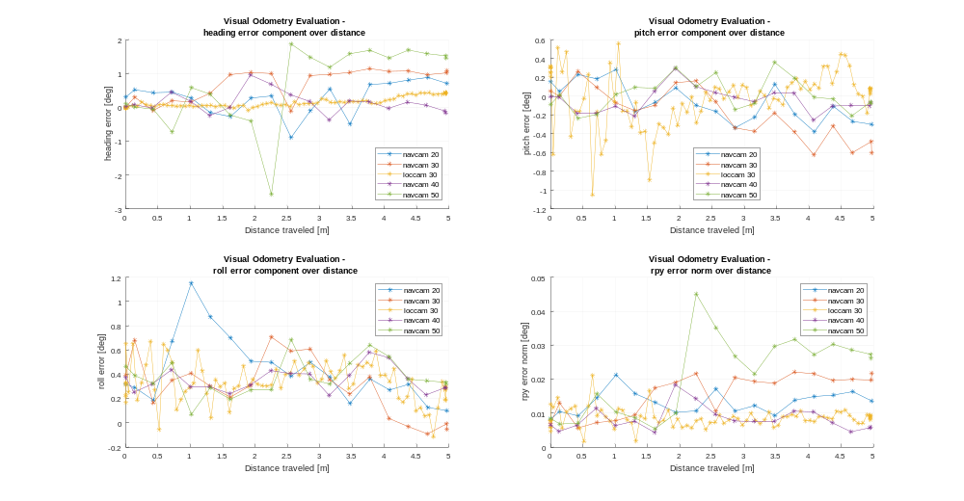

NAVCAM TESTS AT DIFFERENT PITCH VALUES:
Speed = 0.07m/s, Pitch varied from 20deg to 50deg, VO frequency = 1Hz, IFD = 0.07m
navcam pitch = 20deg – IOP = 99.99%
navcam pitch = 30deg – IOP = 98.8165%
navcam pitch = 40deg – IOP = 96.6314%
navcam pitch = 50deg – IOP = 93.5170%
loccam pitch = 30deg – IOP = 96.2243%

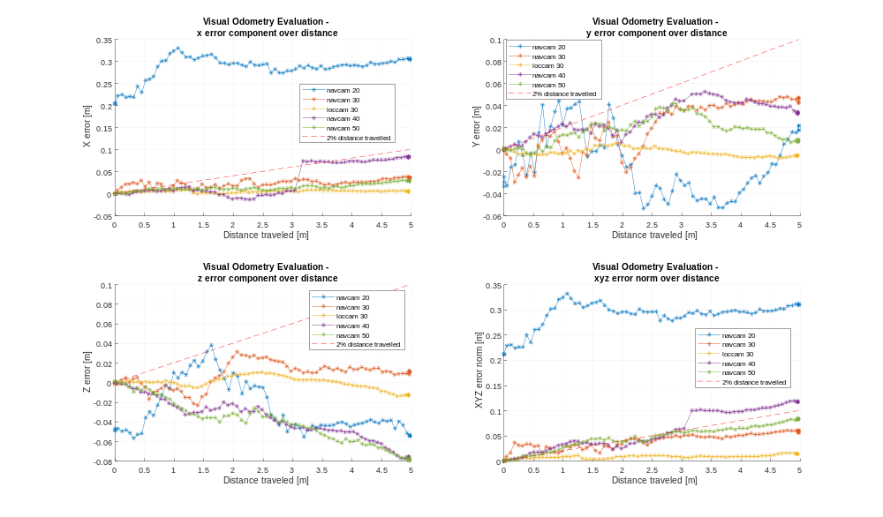
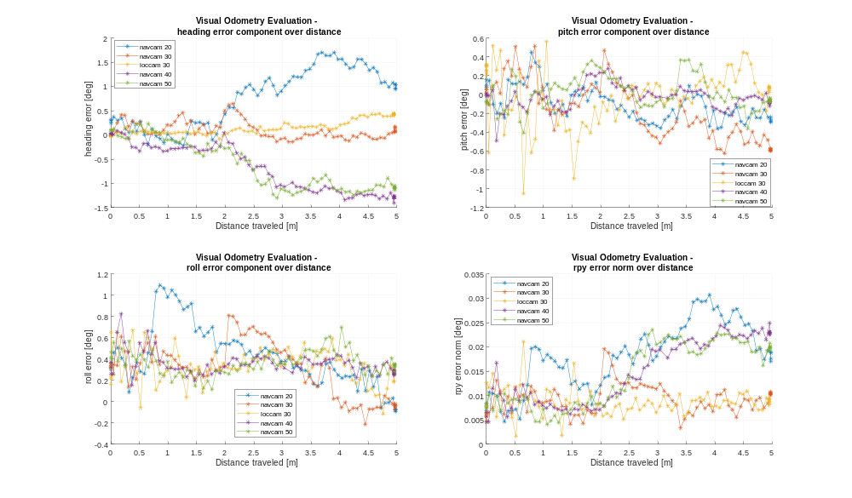
Maybe the IOP has not the same effect when the pitch is changed because the VO does not have far and close features?

COMPARISON BETWEEN LOCCAM AND NAVCAM AT HIGH IOP AND LOW IFD WITH FIXED PITCH:
Test a pitch value that gave good results before and still allows to obtain the IFD and IOP that gave good performances for the loccam.
IOP=93%, IFD=0.1m, speed=0.07m/s, navcam pitch = 37.7
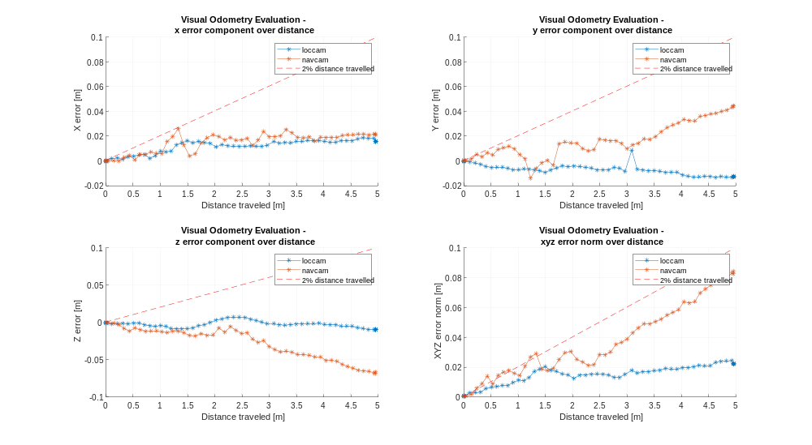
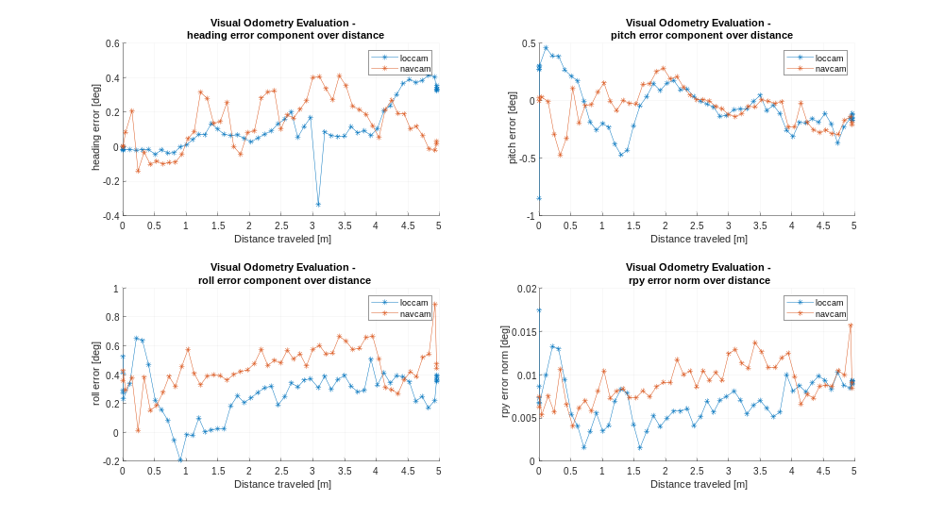

COMPARISON BETWEEN LOCCAM AND NAVCAM AT LOW IOP AND HIGH IFD:
Test a pitch value that gave good results before and still allows to obtain the IFD and IOP that started giving bad performances for the loccam.
IOP=85%, IFD=0.3m, speed=0.07m/s
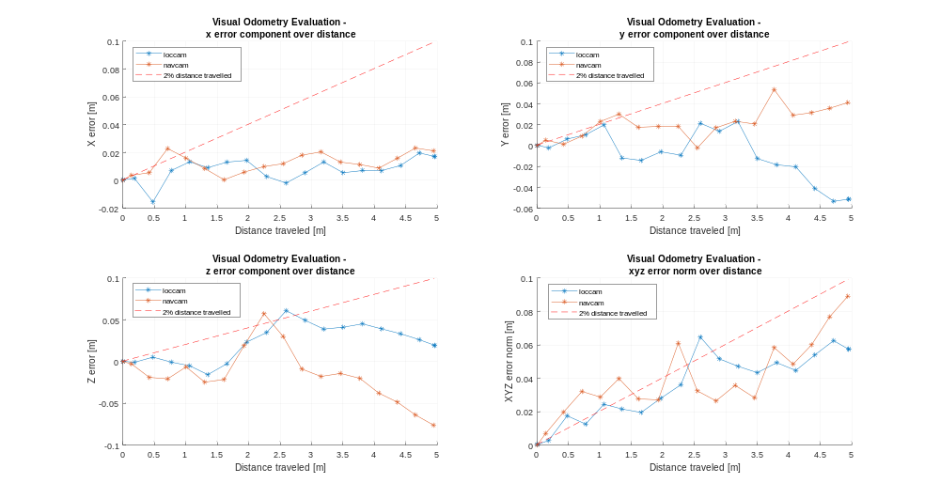
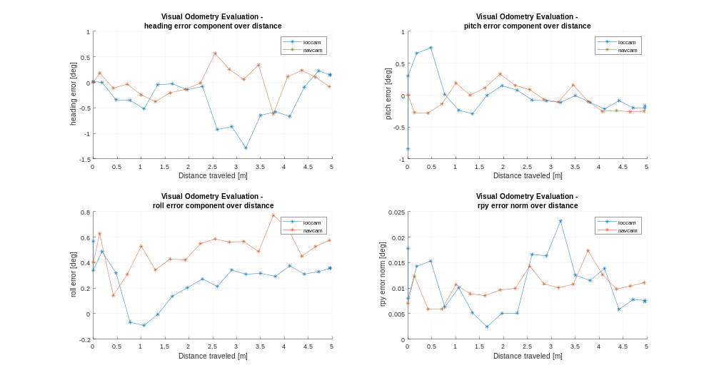
This 2 tests show that the navcam VO mantains the same performances when changing the IFD and IOP through the VO frequency, while the loccam VO shows better performances with lower IFD and higher IOP (IFD = 0.1m and IOP = 93%) with respect to higher IFD and lower IOP (IFD = 0.3m and IOP = 85%)

COMPARISON BETWEEN NAVCAM AND LOCCAM BEST PERFORMANCES:

FUTURE OBJECTIVES:

